**Definition: Develop a webpage using complete Photoshop kit.**

**Solution:**

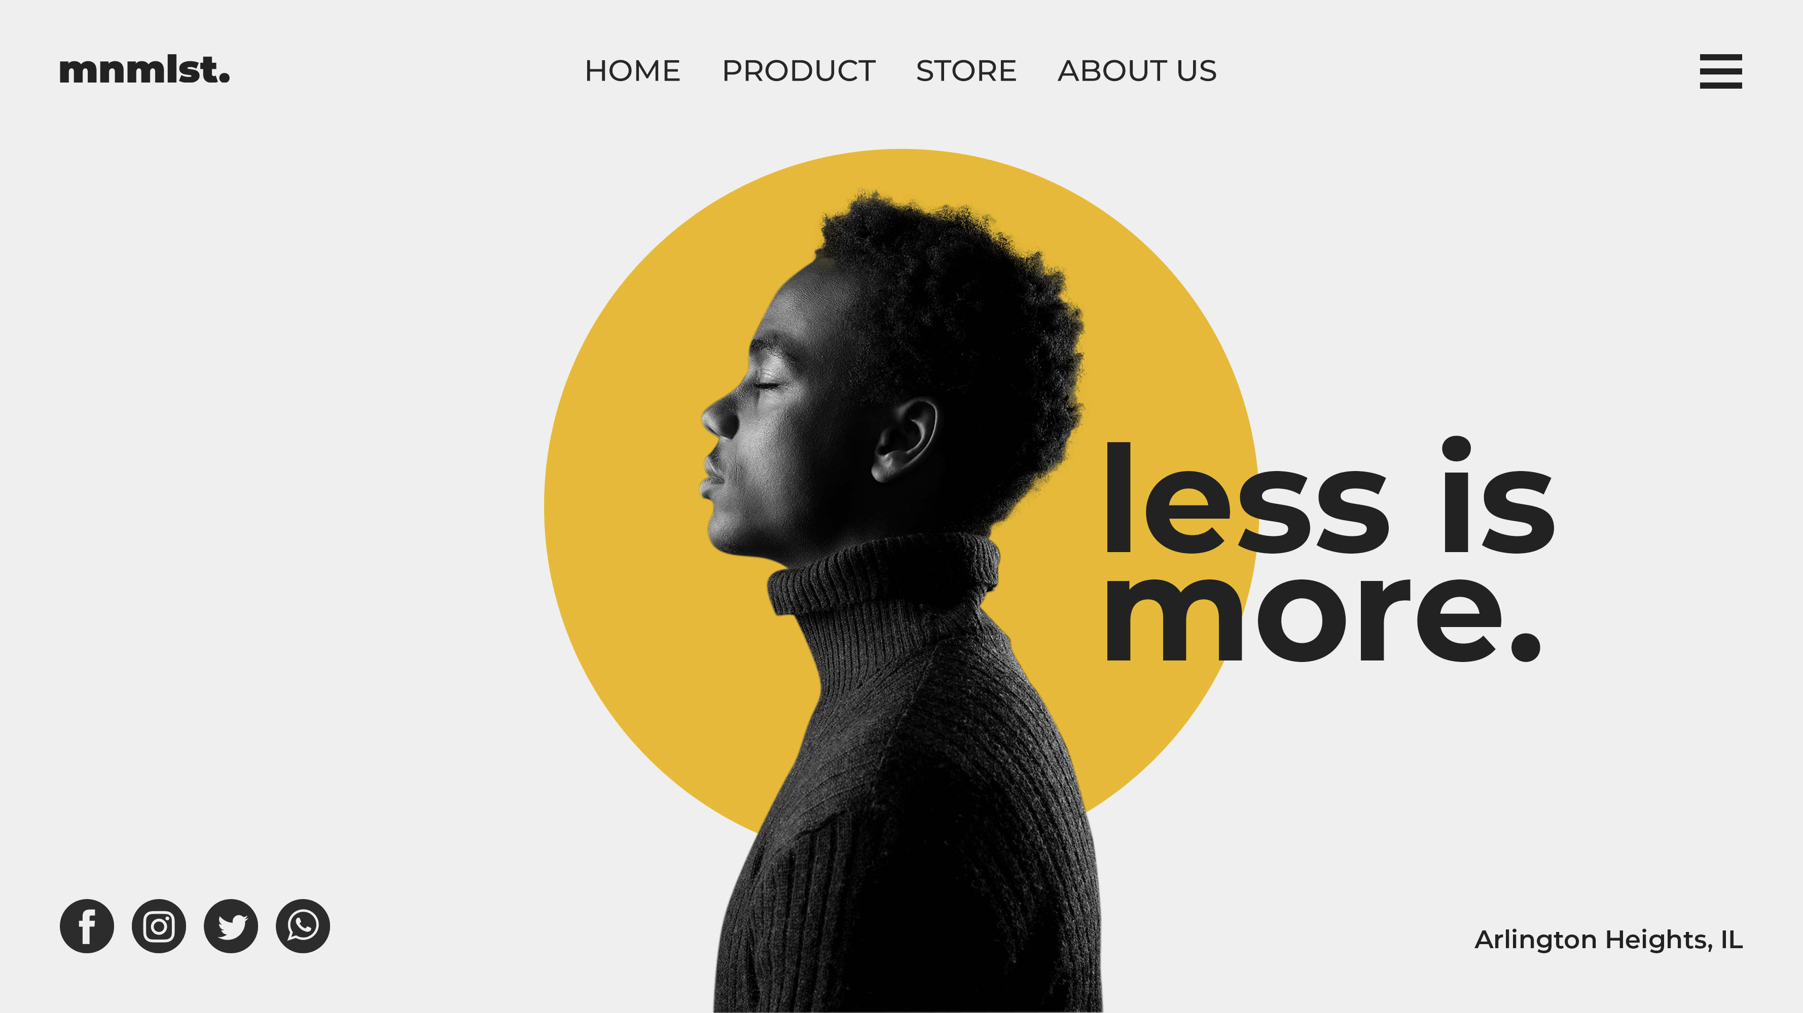

**Steps:**

* First Open photoshop.
* Then create the new document **File à New Photoshop Design.**
* Now add take one frame using the Frame tool and select a Desktop frame of width=”**3556 px**” and height=”**2000 px**” on your canvas.
* First add a **logo** on the top-left side of the frame.
* Now to make navigation bar take Horizontal Type Tool and write “**Home PRODUCT STORE About Us**” of font=”**Montserrat**”, font size=”**14 px**” and color=”**#272727**”.
* Add **Menu** icon on the top-right side of the frame.
* Now on the center if the Frame take an Ellipse of width & height=”**1411 px**” and color=”**#E6BA38**”.
* On the Ellipse take an image of a person as per the above image.
* Write “**Less is more.**” of font=”**Montserrat**”, font size=”**70 px**” and color=”**#222222**”.
* Take the following icons on the bottom-left side of the frame: **Facebook, Instagram, Twitter, WhatsApp.**
* Write **Address** on the bottom-right side of the Frame.
* Now, Go to **File à Save As** And save it with **.PSD/.JPEG/.PNG** format.